Ragan A. Squier
ESF Board of Trustees
Secretary to the Board

M E M O R A N D U M

TO: Members of the ESF Board of Trustees
Diversity, Equity and Inclusion Committee
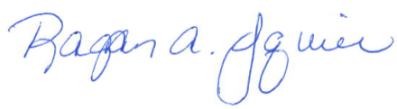
FROM: Ragan A. Squier
Secretary to the Board

DATE: January 27, 2022

TIME: 2:31 PM

SUBJECT: Official Cancellation Notice of the February 2, 2022 Diversity, Equity, and Inclusion Board Committee Meeting

Please be advised, the previously noticed meeting of the Diversity, Equity and Inclusion Committee of the ESF Board of Trustees scheduled for Wednesday, February 2, 2022, from 9-11 AM has been cancelled.

