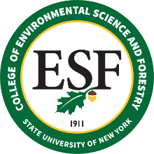

BOARD OF TRUSTEES MEETING
FRIDAY, FEBRUARY 25, 2022

PROPOSED RESOLUTION

RESOLVED that (a) the following individuals be recommended for Continuing Appointment:

(None to report)

that (b) the following individuals be recommended for Permanent Appointment:

Jennifer Cullivan
Senior Staff Assistant
Alumni Relations
January 26, 2023

that (c) the following individuals be recommended for Emeritus Status:

Mark Lomolino
Professor – 10 Months
Environmental Biology
December 31, 2022

that (d) the following individuals be recommended for Sabbatical Leave:

SABBATICAL LEAVE, TITLE E – (none to report)

TITLE F LEAVE – (none to report)

