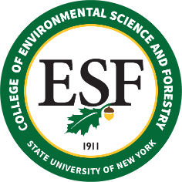

BOARD OF TRUSTEES MEETING
Friday, May 14, 2021

PROPOSED RESOLUTION

WHEREAS, the College owns real property located at 2 Bradford Heights Road, Syracuse, New York 13224, Town of Dewitt (Tax ID: 055.-04-02.0), a single-family residence, ranch style 5 bedrooms, 3 full baths, built in 1955; and

WHEREAS, the College no longer has a use for this property, has obtained approval to abandon the property from the Vice Chancellor for Capital Facilities, and is working to sell the property by auction through the Office of General Services, with the proceeds return to campus; and

WHEREAS, the College operates approximately 25,000 total acres throughout New York State, and the instant parcel is estimated to be approximately 0.46 acres, or 0.00184% of the total acreage; and

WHEREAS, the College obtained two appraisals, with the average value estimated to be $319,700; now, therefore be it

RESOLVED, that the College of Environmental Science and Forestry Board of Trustees endorses the sale of such parcel through auction by the Office of General Services, consistent with the presentation made to the Board.

